DEERWALK INSTITUTE OF TECHNOLOGY

Tribhuvan University

Faculties of Computer Science



**Bachelors of Science in Computer Science and Information Technology**

(B.Sc. CSIT)

Course: Computer Networks (CSC 263)

Class of 2027/Semester: IV

A Lab Report On:

**Implementation of Dynamic Routing protocol using RIPv2 .**

**Submitted by:**

Name: Shaurav Bhandari

Roll No: 1333

**Submitted to:**

Er Rohit Nakarmi

Faculty, Department of Computer Science

# **Lab 6:**

**Objective:**

*Implement a network using RIPv2 in cisco packet tracer.*

**Tools Used:**

* *Cisco Packet Tracer*
* *Router-PT*
* *Switch-PT*
* *VPCs, Laptops*

**Logical Topology Diagram:**

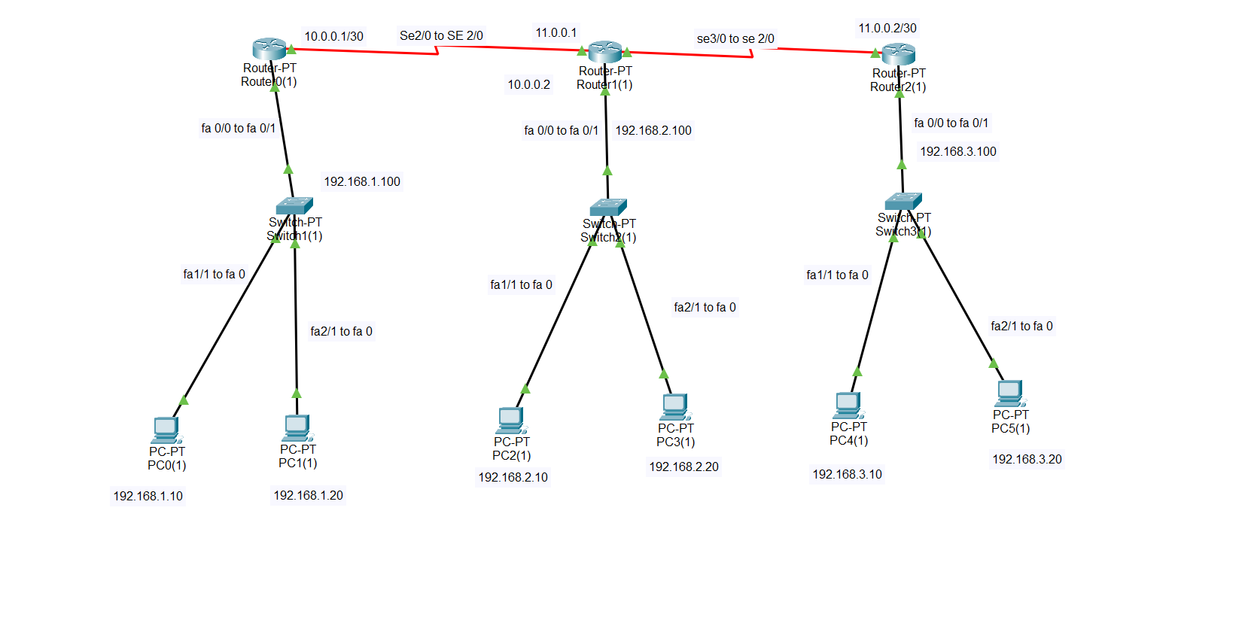

* **Configuration of routers:**
  + **Router 0:**

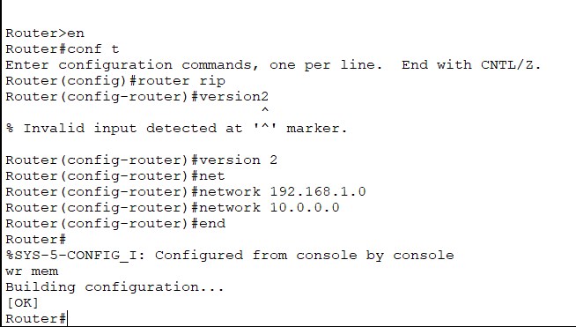

* + **Router 1:**

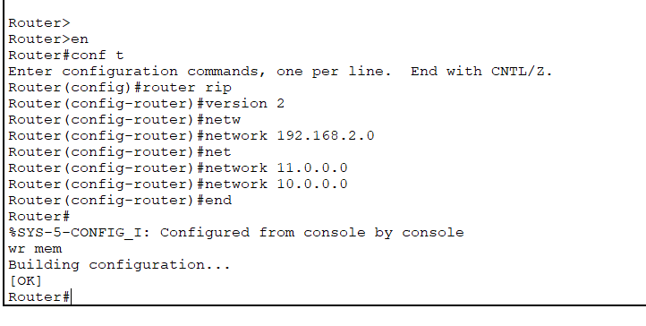

* + **Router 2:**

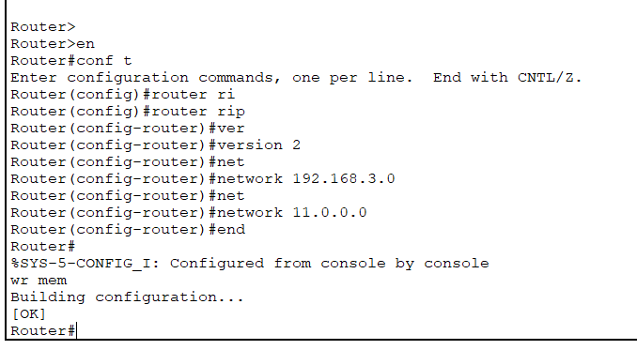

* **Interface configuration and route verifications:**
  + **Interface brief:**
    - **Router 0:**

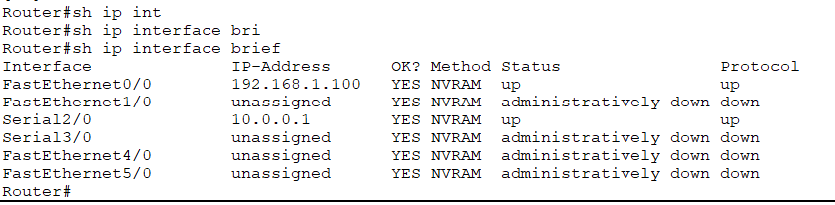

* + - **Router 1:**

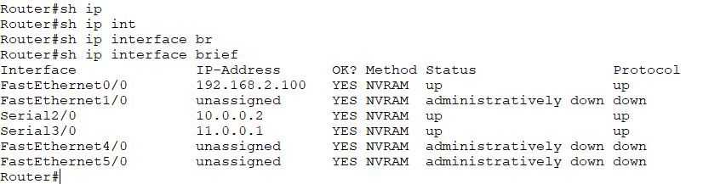

* + - **Router 2:**

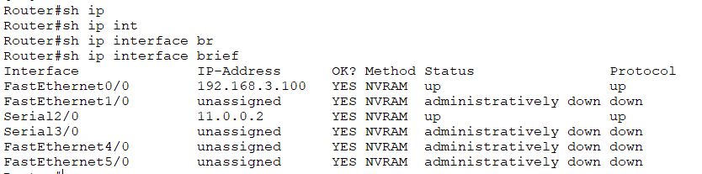

* + **Ip routes:**
    - **Router 0:**

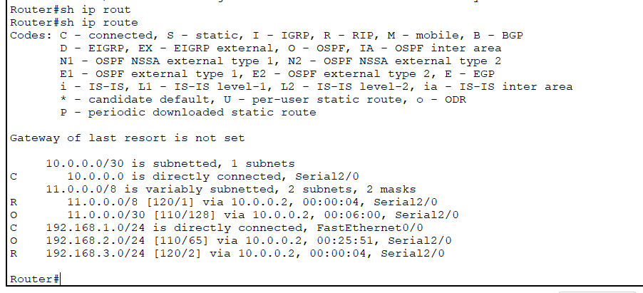

* + - **Router 1:**

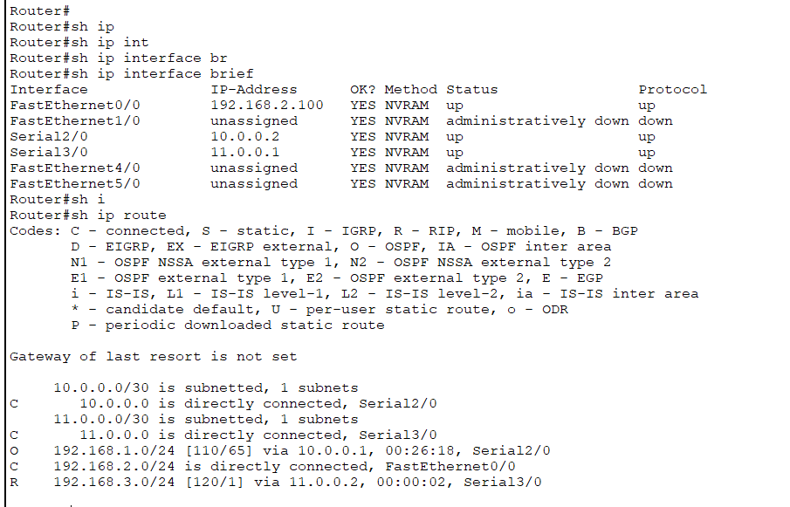

* + - **Router 2:**

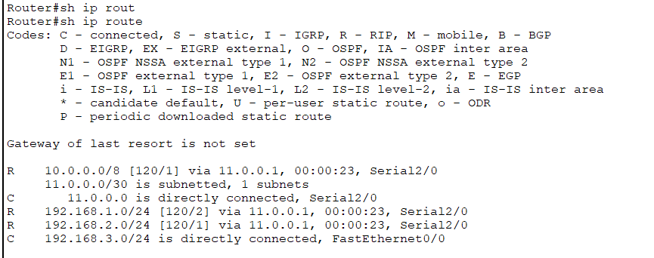

* + **Ip protocols:**
    - **Router 0:**

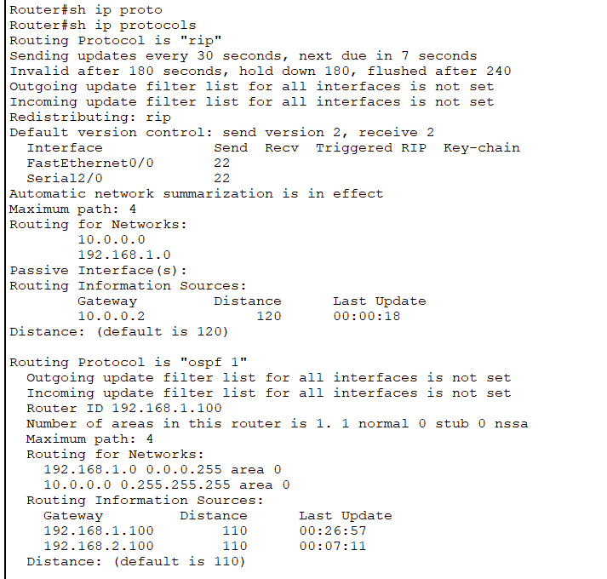

* + - **Router 1:**

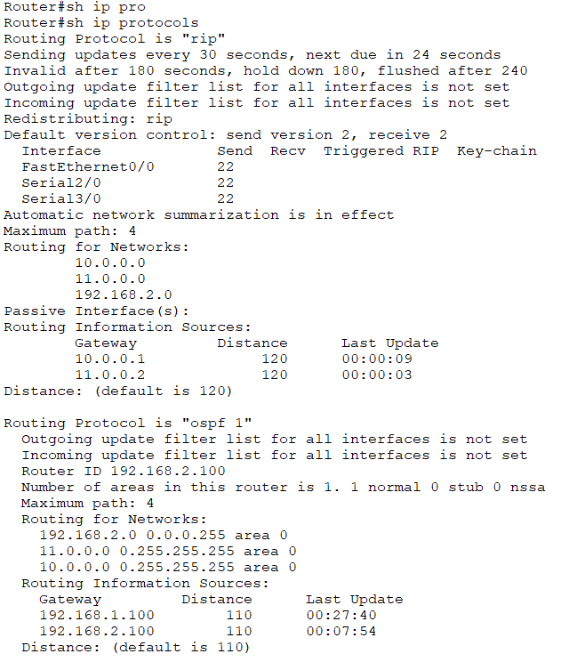

* + - **Router 2:**

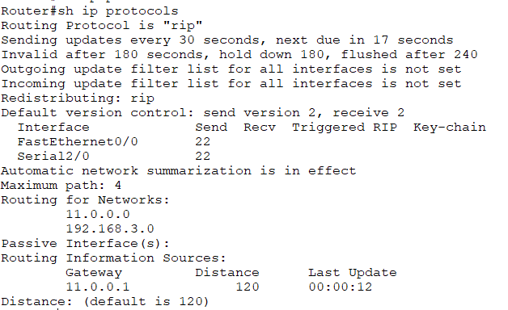

* + **RIP database:**
    - **Router 0:**

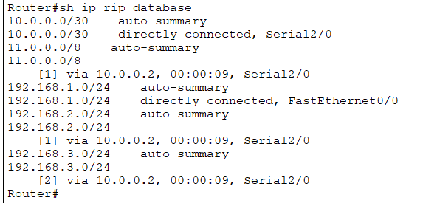

* + - **Router 1:**

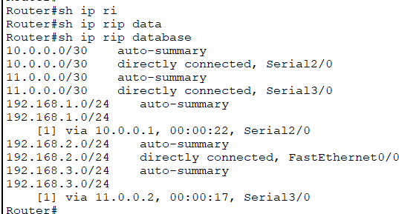

* + - **Router 2:**

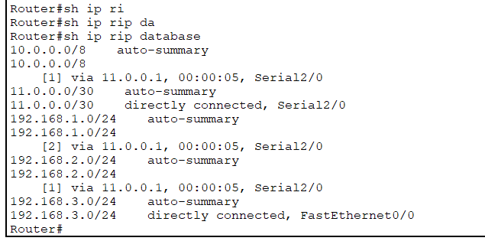

* **Pinging from Devices:**
  + **PC 0:**

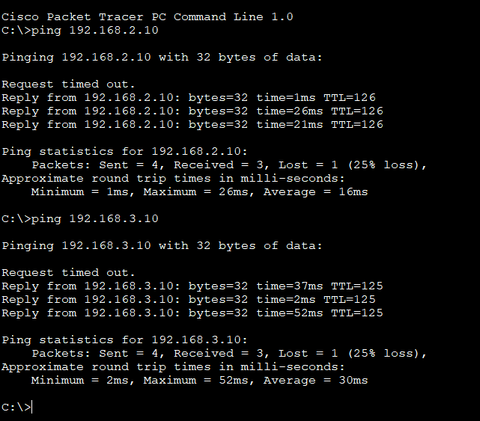

* + **PC 3:**

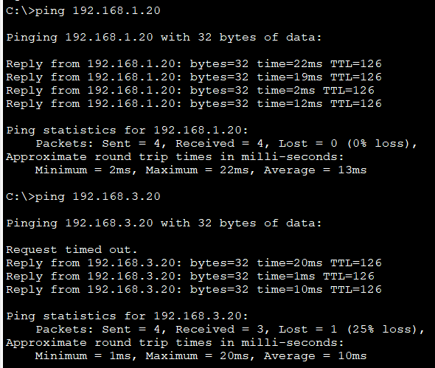

* + **PC 5:**

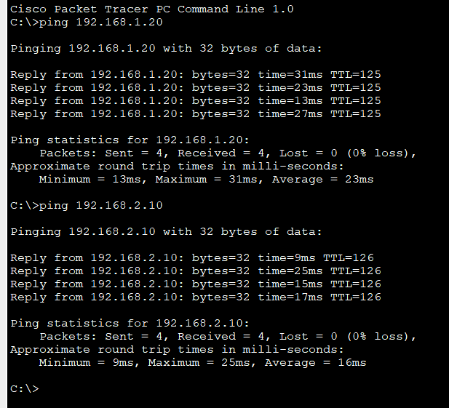

***Conclusion:***

Hence, the network was designed to implement and verify the features of Routing Information protocol version 2(RIPv2),which enabled communication between the virtual devices in the network communicate through dynamic routing.